**ADMIN-PORTAL**

This document contains sections for:

* Sprint planning and Task completion
* Core concepts used in project
* Flow of the Application.
* Demonstrating the product capabilities, appearance, and user interactions.
* Conclusions

The project is developed by SADHU VENKATA SAI KUMAR.

The code for this project is hosted at:

<https://github.com/Mohammedirshad1997/ADMIN-PORTAL.git>

## Sprints planning and Task completion

The project is planned to be completed in 1 sprint. Tasks assumed to be completed in the sprint are:

* Creating the flow of the application
* Initializing git repository to track changes as development progresses.
* Writing the Java program to fulfill the requirements of the project.
* Testing the Java program with different kinds of User input
* Pushing code to GitHub.
* Creating this specification document highlighting application capabilities, appearance, and user interactions.

## Technologies and tools Used

* • Servlet: to do the business logic and works a controller for the project.
* • JSP and HTML: to handle the presentation view.
* • SQL: to create and manage the database.
* • JDBC: to make operations on the database for the project.
* • CSS: to format the contents and load image files.
* • Mysql workbench: to administrate and manage the database manually.
* • Eclipse: to write and run the code.
* • Tomcat 9 : to run and deploy servlet application.

Product Backlog:

* Create database and tables.
* Connect the database to the project.
* Create models classes.
* Create a database utility class to retrieve data.
* Create login page.
* Create HTML and JSP files for pages of the project.
* Create a servlet to get requests and send responses to the JSP and HTML files.
* Add cookies.
* Create a CSS file to format the contents.
* Debug and Test the project.

## Flow of the Application:

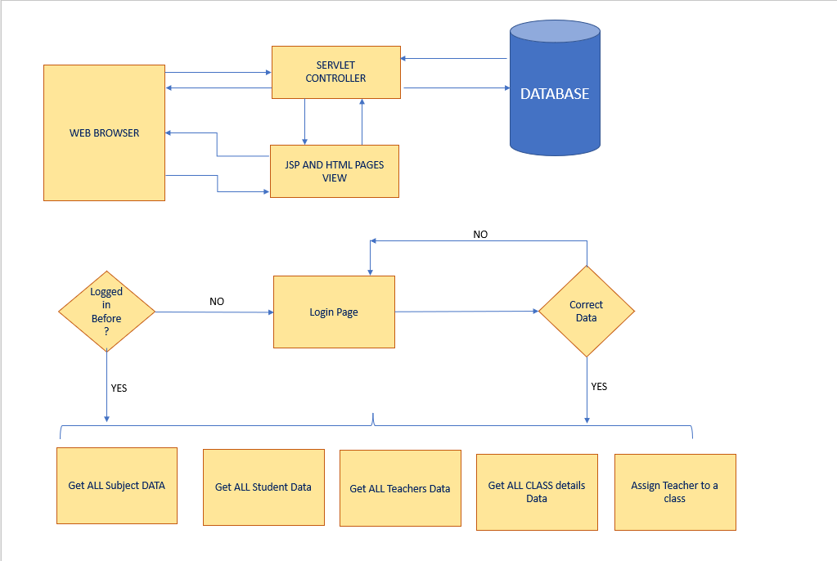

## Demonstrating the product capabilities, appearance, and user interactions

To demonstrate the product capabilities, below are the sub-sections configured to highlight appearance and user interactions for the project:

1. Creating the Dynamic Web project in Eclipse
2. Creating HTML Files
3. Creating Servlet
4. Creating Java class files
5. Creating css file
6. Screenshots

## **Step 1:** Creating a new project in Eclipse

* Open Eclipse
* Go to File -> New -> Project -> Dynamic Web Project -> Next.
* Type in any project name and click on “Finish.”
* Select your project and go to Webapp -> New -> HTML file.

## **Step 2:** Writing a HTML Code for login front end

<!DOCTYPE html>

<html>

<head>

<title>Login</title>

<meta charset=*"ISO-8859-1"*>

<style>

**p** {

background-image: *url('css/11.jpg')*;

}

</style>

<link type=*"text/css"* rel=*"stylesheet"* href=*"css/login.css"*>

</head>

<body style="background-image: *url('css/11.jpg')*;">

<center> <h1> Admin Login </h1> </center>

<form action=*"checkPass"*>

<div class=*"container"*>

<input type=*"hidden"* name=*"command"* value=*"LOGIN"* />

<label>Username : </label>

<br/>

<input type=*"text"* name=*"uname"*><br>

<br/>

<label>Password : </label>

<br/>

<input type=*"password"* name=*"upass"*><br>

<br/>

<input type=*"submit"* value=*"LOGIN"*>

<br/>

<input type=*"checkbox"* checked=*"checked"*> Remember me

</div>

</form>

</body>

</html>

**OUTPUT:**

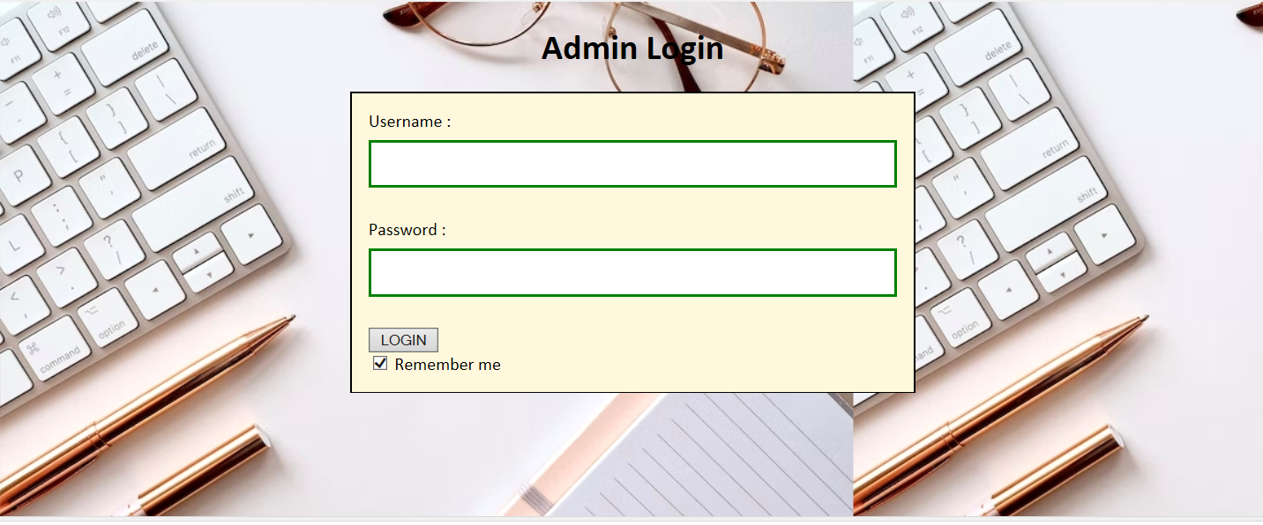

## **Step 3:** Writing a HTML Code for Admin Main screen:

<!DOCTYPE html>

<html>

<head>

<meta charset=*"ISO-8859-1"*>

<title>Insert title here</title>

<link type=*"text/css"* rel=*"stylesheet"* href=*"css/style.css"*>

</head>

<body style="background-image: *url('css/11.jpg')*;">

<h4>----------------WELCOME ADMIN----------------</h4>

<form action=*"StudentsServlet"*>

<br><input type=*"submit"* value=*"LIST STUDENTS"*><br><br>

</form>

<form action=*"TeachersServlet"*>

<input type=*"submit"* value=*"LIST TEACHERS"*><br><br>

</form>

<form action=*"AllSubjects"*>

<input type=*"submit"* value=*"LIST SUBJECTS"*><br><br>

</form>

<form action=*"Assign.html"*>

<input type=*"submit"* value=*"ASSIGN"*><br><br>

</form>

<form action=*"ClassAssigned.jsp"*>

<input type=*"submit"* value=*"CLASS REPORT"*><br><br>

</form>

<form action=*"AdminPage.html"*>

<input type=*"submit"* value=*"LOGOUT"*><br><br>

</form>

</body>

</html>

**OUTPUT:**

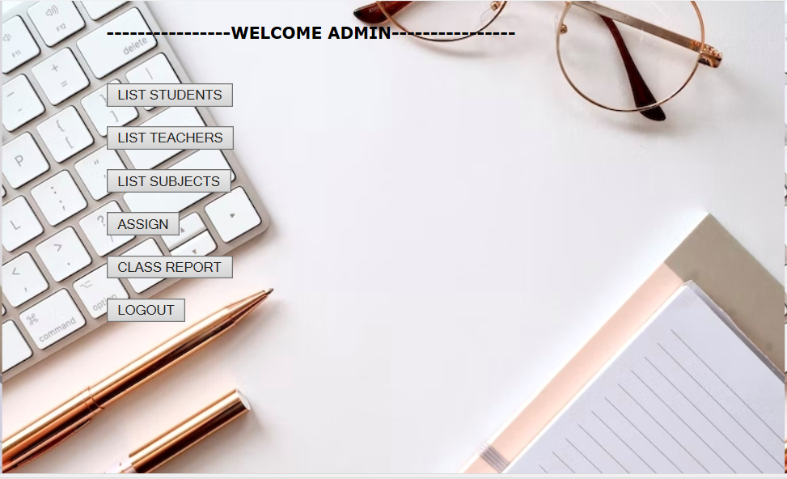

## **Step 4:** Writing a HTML code Assign Function for a Radio buttons:

<!DOCTYPE html>

<html>

<head>

<meta charset=*"ISO-8859-1"*>

<title>Insert title here</title>

</head>

<body style="background-image: *url('css/back.jpg')*;">

<form action=*"AssignServlet"*>

<br>

<br>

<br>

<br>

<br>

<h4><center>Select Class:</h4>

<center><input type=*"radio"* name=*"r1"* value=*"8"*>Class 8<br>

<center><input type=*"radio"* name=*"r1"* value=*"9"*>Class 9<br>

<center><input type=*"radio"* name=*"r1"* value=*"10"*>Class 10<br><br>

<input type=*"submit"* value=*"Next"*>

</form>

</body>

</html>

**OUTPUT:**



## **Step 5:** Writing a JSP code to retrieve data from database to display:

<%@ page language=*"java"* contentType=*"text/html; charset=UTF-8"*

pageEncoding=*"UTF-8"*%>

<%@page import=*"java.sql.*"* %>

<%@page import=*"java.sql.DriverManager"* %>

<%@page import=*"java.sql.PreparedStatement"* %>

<%@page import=*"java.sql.SQLException"* %>

<%

Connection con;

PreparedStatement pstm;

ResultSet rsuser;

**int** StudentId;

String StudenName,Subject,TeacherAssign;

%>

<!DOCTYPE html>

<html>

<head>

<meta charset=*"UTF-8"*>

<title>Insert title here</title>

</head>

<body style="background-image: *url('css/back.jpg')*;">

<H1>CLASS REPORT</H1>

<form action= *"ClassAssigned.jsp"* method=*"post"*>

<div style="width: *50%*; height:*1000px*;border-style:*solid*;border-width:*2px*;border-color:*brown*">

<table style="width: *10%*; height:*100px*;border-style:*solid*;border-width:*1px*;border-color:*blue*">

<thead>

<th style="width: *10%*; height:*20px*;border-style:*solid*;border-width:*1px*;border-color:*blue*">StudentId</th>

<th style="width: *20%*; height:*20px*;border-style:*solid*;border-width:*1px*;border-color:*blue*">StudenName</th>

<th style="width: *20%*; height:*20px*;border-style:*solid*;border-width:*1px*;border-color:*blue*">Subject</th>

<th style="width: *40%*; height:*20px*;border-style:*solid*;border-width:*1px*;border-color:*blue*">TeacherAssign</th>

</thead>

<tbody>

<%

**try**{

Class.forName("com.mysql.jdbc.Driver");

con=DriverManager.getConnection("jdbc:mysql://localhost:3306/school", "root", "Invisible16");

pstm = con.prepareStatement("select * from classreport");

rsuser= pstm.executeQuery();

**while**(rsuser.next())

{

StudentId=rsuser.getInt(1);

StudenName=rsuser.getString(2);

Subject=rsuser.getString(3);

TeacherAssign=rsuser.getString(5);

%>

<tr>

<th style="width: *10%*; height:*20px*;border-style:*solid*;border-width:*1px*;border-color:*blue*"><%=StudentId%></th>

<th style="width: *20%*; height:*20px*;border-style:*solid*;border-width:*1px*;border-color:*blue*"><%=StudenName%></th>

<th style="width: *20%*; height:*20px*;border-style:*solid*;border-width:*1px*;border-color:*blue*"><%=Subject%></th>

<th style="width: *40%*; height:*20px*;border-style:*solid*;border-width:*1px*;border-color:*blue*"><%=TeacherAssign%></th>

</tr>

<%}

}

**catch**(Exception ex){

%>

<script>

alert("Problem in Retriving data:-"+<% ex.toString(); %>);

</script>

<%

}

%>

</tbody>

</table>

</center>

</table>

</div>

</body>

</html>

**OUTPUT:**

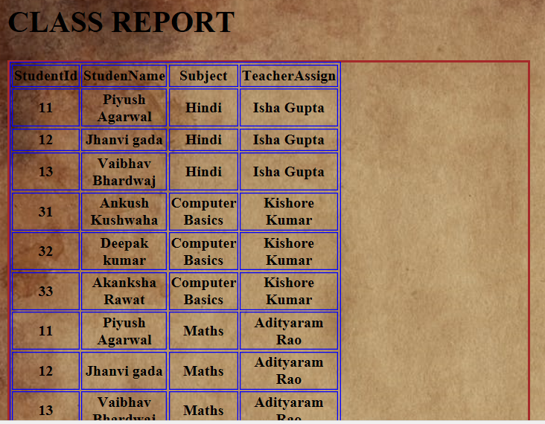

## **Step 6:** Writing a CSS code for login screen:

**Body** {

font-family: *Calibri,* *Helvetica,* *sans-serif*;

background-color: *pink*;

}

**button** {

justify-content: *center*;

background-color: *#4CAF50*;

width: *100%*;

color: *white*;

padding: *15px*;

margin: *10px* *0px*;

border: *none*;

cursor: *pointer*;

}

**form** {

border: *1.4px* *solid* *black*;

width: *45%*;

margin: *0* *auto*;

}

**input**[type=text]**,** **input**[type=password] {

justify-content: *center*;

width: *100%*;

margin: *8px* *0*;

padding: *12px* *20px*;

display: *inline-block*;

border: *2px* *solid* *green*;

box-sizing: *border-box*;

}

**button***:hover* {

opacity: *0.7*;

}

*.container* {

justify-content: *center*;

padding: *15px*;

background-color: *#FFF8DC*;

}

**OUTPUT:**

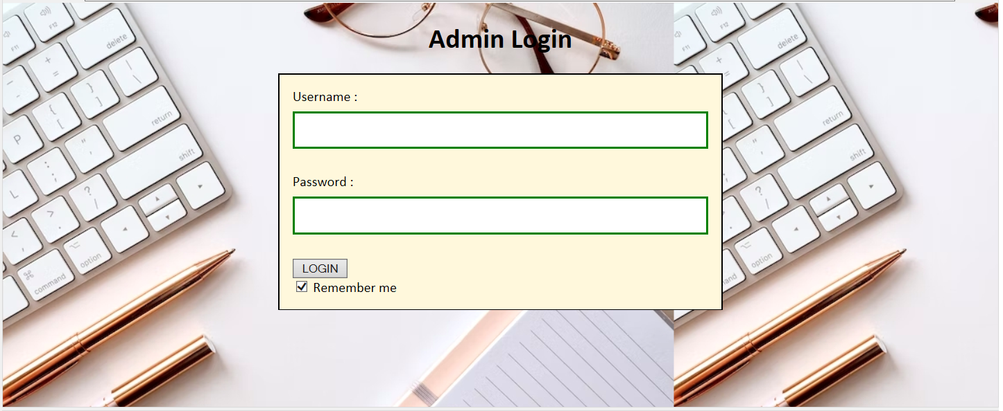

***Under CSS file you can insert all the backgroup image files to easily retrieve it inside eclip***

## **Step 7:** Writing a XML code to Direct pages:

<?xml version=*"1.0"* encoding=*"UTF-8"*?>

<web-app xmlns:xsi=*"http://www.w3.org/2001/XMLSchema-instance"* xmlns=*"http://xmlns.jcp.org/xml/ns/javaee"* xsi:schemaLocation=*"http://xmlns.jcp.org/xml/ns/javaee http://xmlns.jcp.org/xml/ns/javaee/web-app_3_1.xsd"* id=*"WebApp_ID"* version=*"3.1"*>

<display-name>Administrative</display-name><display-name>Admin_Portal</display-name>

<welcome-file-list>

<welcome-file>AdminPage.html</welcome-file>

<welcome-file>index.html</welcome-file>

<welcome-file>index.jsp</welcome-file>

<welcome-file>index.htm</welcome-file>

<welcome-file>default.html</welcome-file>

<welcome-file>default.jsp</welcome-file>

<welcome-file>default.htm</welcome-file>

</welcome-file-list>

<servlet>

<description></description>

<display-name>TeachersServlet</display-name>

<servlet-name>TeachersServlet</servlet-name>

<servlet-class>com.TeachersServlet</servlet-class>

</servlet>

<servlet-mapping>

<servlet-name>TeachersServlet</servlet-name>

<url-pattern>/TeachersServlet</url-pattern>

</servlet-mapping>

<servlet>

<description></description>

<display-name>StudentsServlet</display-name>

<servlet-name>StudentsServlet</servlet-name>

<servlet-class>com.StudentsServlet</servlet-class>

</servlet>

<servlet-mapping>

<servlet-name>StudentsServlet</servlet-name>

<url-pattern>/StudentsServlet</url-pattern>

</servlet-mapping>

<servlet>

<description></description>

<display-name>AllSubjects</display-name>

<servlet-name>AllSubjects</servlet-name>

<servlet-class>com.AllSubjects</servlet-class>

</servlet>

<servlet-mapping>

<servlet-name>AllSubjects</servlet-name>

<url-pattern>/AllSubjects</url-pattern>

</servlet-mapping>

<servlet>

<description></description>

<display-name>Class8Subj</display-name>

<servlet-name>Class8Subj</servlet-name>

<servlet-class>com.Class8Subj</servlet-class>

</servlet>

<servlet-mapping>

<servlet-name>Class8Subj</servlet-name>

<url-pattern>/Class8Subj</url-pattern>

</servlet-mapping>

<servlet>

<description></description>

<display-name>Class9Subj</display-name>

<servlet-name>Class9Subj</servlet-name>

<servlet-class>com.Class9Subj</servlet-class>

</servlet>

<servlet-mapping>

<servlet-name>Class9Subj</servlet-name>

<url-pattern>/Class9Subj</url-pattern>

</servlet-mapping>

<servlet>

<description></description>

<display-name>Class10Subj</display-name>

<servlet-name>Class10Subj</servlet-name>

<servlet-class>com.Class10Subj</servlet-class>

</servlet>

<servlet-mapping>

<servlet-name>Class10Subj</servlet-name>

<url-pattern>/Class10Subj</url-pattern>

</servlet-mapping>

<servlet>

<description></description>

<display-name>AssignServlet</display-name>

<servlet-name>AssignServlet</servlet-name>

<servlet-class>com.AssignServlet</servlet-class>

</servlet>

<servlet-mapping>

<servlet-name>AssignServlet</servlet-name>

<url-pattern>/AssignServlet</url-pattern>

</servlet-mapping>

<servlet>

<description></description>

<display-name>AssignTo</display-name>

<servlet-name>AssignTo</servlet-name>

<servlet-class>com.AssignTo</servlet-class>

</servlet>

<servlet-mapping>

<servlet-name>AssignTo</servlet-name>

<url-pattern>/AssignTo</url-pattern>

</servlet-mapping>

<servlet>

<description></description>

<display-name>AssignTo10</display-name>

<servlet-name>AssignTo10</servlet-name>

<servlet-class>com.AssignTo10</servlet-class>

</servlet>

<servlet-mapping>

<servlet-name>AssignTo10</servlet-name>

<url-pattern>/AssignTo10</url-pattern>

</servlet-mapping>

<servlet>

<description></description>

<display-name>checkPass</display-name>

<servlet-name>checkPass</servlet-name>

<servlet-class>com.checkPass</servlet-class>

</servlet>

<servlet-mapping>

<servlet-name>checkPass</servlet-name>

<url-pattern>/checkPass</url-pattern>

</servlet-mapping>

</web-app>

## **Step 8:** Writing a program to display Teacher details from database:

package com;

import java.io.IOException;

import java.io.PrintWriter;

import java.sql.Connection;

import java.sql.DriverManager;

import java.sql.ResultSet;

import java.sql.Statement;

import javax.servlet.ServletException;

import javax.servlet.http.HttpServlet;

import javax.servlet.http.HttpServletRequest;

import javax.servlet.http.HttpServletResponse;

/**

* Servlet implementation class TeachersServlet

*/

public class TeachersServlet extends HttpServlet {

private static final long serialVersionUID = 1L;

/**

* @see HttpServlet#HttpServlet()

*/

public TeachersServlet() {

super();

// TODO Auto-generated constructor stub

}

protected void doGet(HttpServletRequest request, HttpServletResponse response) throws ServletException, IOException {

PrintWriter out = response.getWriter();

try {

Class.forName("com.mysql.jdbc.Driver");

Connection connect = DriverManager.getConnection("jdbc:mysql://localhost:3306/school","root","Invisible16");

Statement stmt = connect.createStatement();

ResultSet rs = stmt.executeQuery("select * from listteachers");

out.println("<body style=\"background-image: url('css/back.jpg');\">");

while(rs.next()) {

out.println("<div style=\"width: 50%; height:100px;border-style:solid;border-width:2px;border-color:blue>");

out.println("<table style=\"width: 50%; height:100px;border-style:solid;border-width:2px;border-color:blue>");

out.println("<br><center>"+"Name: "+rs.getString("name")+"<br><center>"+"Subject: "+rs.getString("subject")+"<br>");

out.println("<center>"+"-------------------------------");

out.println("</table>");

out.println("</div>");

}

out.println("<div style=\"width: 50%; height:100px;border-style:solid;border-width:2px;border-color:blue><table style=\\\"width: 50%; height:100px;border-style:solid;border-width:2px;border-color:blue><br><center>"+"<a href='Admin.html'>Back to Dashboard</a></table></div>");

out.println("</body>");

} catch (Exception e) {

System.out.println(e);

}

}

protected void doPost(HttpServletRequest request, HttpServletResponse response) throws ServletException, IOException {

// TODO Auto-generated method stub

doGet(request, response);

}

}

**OUTPUT:**

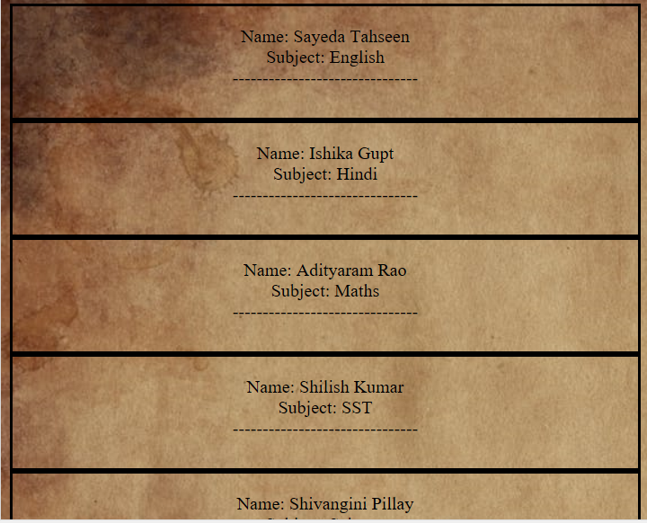

## **Step 9:** Writing a program to display Student details from database:

package com;

import java.io.IOException;

import java.io.PrintWriter;

import java.sql.Connection;

import java.sql.DriverManager;

import java.sql.ResultSet;

import java.sql.Statement;

import javax.servlet.ServletException;

import javax.servlet.http.HttpServlet;

import javax.servlet.http.HttpServletRequest;

import javax.servlet.http.HttpServletResponse;

/**

* Servlet implementation class StudentsServlet

*/

public class StudentsServlet extends HttpServlet {

private static final long serialVersionUID = 1L;

/**

* @see HttpServlet#HttpServlet()

*/

public StudentsServlet() {

super();

// TODO Auto-generated constructor stub

}

/**

* @see HttpServlet#doGet(HttpServletRequest request, HttpServletResponse response)

*/

protected void doGet(HttpServletRequest request, HttpServletResponse response) throws ServletException, IOException {

PrintWriter out = response.getWriter();

try {

Class.forName("com.mysql.jdbc.Driver");

Connection connect = DriverManager.getConnection("jdbc:mysql://localhost:3306/school","root","Invisible16");

Statement stmt = connect.createStatement();

ResultSet rs = stmt.executeQuery("select * from ListStudents");

out.println("<body style=\"background-image: url('css/back.jpg');\">");

while(rs.next()) {

out.println("<div style=\"width: 50%; height:100px;border-style:solid;border-width:2px;border-color:blue><center>");

out.println("<table style=\"width: 50%; height:100px;border-style:solid;border-width:2px;border-color:blue><center>");

out.println("<br><center>"+"ID: "+rs.getInt("Id")+"<br><center>"+"Name: "+rs.getString("name")+"<br><center>"+"Class: "+rs.getString("class")+"<br>");

out.println("<center>"+"-------------------------------");

out.println("</table>");

out.println("</div>");

}

out.println("<div style=\"width: 50%; height:100px;border-style:solid;border-width:2px;border-color:blue><table style=\\\"width: 50%; height:100px;border-style:solid;border-width:2px;border-color:blue><br><center>"+"<a href='Admin.html'>Back to Dashboard</a></table></div>");

out.println("</body>");

} catch (Exception e) {

System.out.println(e);

}

}

protected void doPost(HttpServletRequest request, HttpServletResponse response) throws ServletException, IOException {

// TODO Auto-generated method stub

doGet(request, response);

}

}

**OUTPUT:**

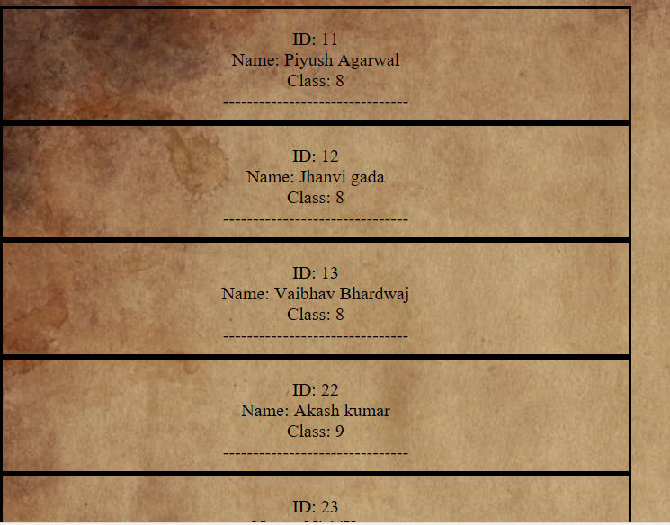

## **Step 10:** Writing a program to display ALL the subjects from database:

package com;

import java.io.IOException;

import java.io.PrintWriter;

import javax.servlet.ServletException;

import javax.servlet.http.HttpServlet;

import javax.servlet.http.HttpServletRequest;

import javax.servlet.http.HttpServletResponse;

/**

* Servlet implementation class AllSubjects

*/

public class AllSubjects extends HttpServlet {

private static final long serialVersionUID = 1L;

/**

* @see HttpServlet#HttpServlet()

*/

public AllSubjects() {

super();

// TODO Auto-generated constructor stub

}

protected void doGet(HttpServletRequest request, HttpServletResponse response) throws ServletException, IOException {

PrintWriter out = response.getWriter();

out.println("<body style=\"background-image: url('css/back.jpg');\"><center><h4><br><br><br><br><br>Select any class from below to view Subjects: </h4><form action='Class8Subj'> <input type='submit' value='Class 8 subjects'></form>"+" "+"<form action='Class9Subj'> <input type='submit' value='Class 9 subjects'></form>"+"<form action='Class10Subj'> <input type='submit' value='Class 10 subjects'></form>");

out.println("</body>");

}

protected void doPost(HttpServletRequest request, HttpServletResponse response) throws ServletException, IOException {

// TODO Auto-generated method stub

doGet(request, response);

}

}

**OUTPUT:**



## **Step 11:** Writing a program to Retrieve Class 8 subjects:

package com;

import java.io.IOException;

import java.io.PrintWriter;

import java.sql.Connection;

import java.sql.DriverManager;

import java.sql.ResultSet;

import java.sql.Statement;

import javax.servlet.ServletException;

import javax.servlet.http.HttpServlet;

import javax.servlet.http.HttpServletRequest;

import javax.servlet.http.HttpServletResponse;

/**

* Servlet implementation class Class8Subj

*/

public class Class8Subj extends HttpServlet {

private static final long serialVersionUID = 1L;

/**

* @see HttpServlet#HttpServlet()

*/

public Class8Subj() {

super();

// TODO Auto-generated constructor stub

}

/**

* @see HttpServlet#doGet(HttpServletRequest request, HttpServletResponse response)

*/

protected void doGet(HttpServletRequest request, HttpServletResponse response) throws ServletException, IOException {

PrintWriter out = response.getWriter();

try {

Class.forName("com.mysql.jdbc.Driver");

Connection connect = DriverManager.getConnection("jdbc:mysql://localhost:3306/school","root","Invisible16");

Statement stmt = connect.createStatement();

ResultSet rs = stmt.executeQuery("select subjects from allsubjects where type='regular'");

out.println("<body style=\"background-image: url('css/back.jpg');\">");

while(rs.next()) {

out.println("<center>"+"Class 8 Subjects");

out.println("<br>"+"<strong>"+rs.getString("subjects")+"</strong>"+"<br>");

out.println("--------------");

}

out.println("<br>"+"<a href='Admin.html'>Back to Main Menu</a>'");

out.println("</body>");

} catch (Exception e) {

System.out.println(e);

}

}

/**

* @see HttpServlet#doPost(HttpServletRequest request, HttpServletResponse response)

*/

protected void doPost(HttpServletRequest request, HttpServletResponse response) throws ServletException, IOException {

// TODO Auto-generated method stub

doGet(request, response);

}

}

**OUTPUT:**

## 

## **Step 12:** Writing a program to Retrieve Class 9 subjects:

package com;

import java.io.IOException;

import java.io.PrintWriter;

import java.sql.Connection;

import java.sql.DriverManager;

import java.sql.ResultSet;

import java.sql.Statement;

import javax.servlet.ServletException;

import javax.servlet.http.HttpServlet;

import javax.servlet.http.HttpServletRequest;

import javax.servlet.http.HttpServletResponse;

/**

* Servlet implementation class Class9Subj

*/

public class Class9Subj extends HttpServlet {

private static final long serialVersionUID = 1L;

/**

* @see HttpServlet#HttpServlet()

*/

public Class9Subj() {

super();

// TODO Auto-generated constructor stub

}

/**

* @see HttpServlet#doGet(HttpServletRequest request, HttpServletResponse response)

*/

protected void doGet(HttpServletRequest request, HttpServletResponse response) throws ServletException, IOException {

PrintWriter out = response.getWriter();

try {

Class.forName("com.mysql.jdbc.Driver");

Connection connect = DriverManager.getConnection("jdbc:mysql://localhost:3306/school","root","Invisible16");

Statement stmt = connect.createStatement();

ResultSet rs = stmt.executeQuery("select subjects from allsubjects where type='regular'");

out.println("<body style=\"background-image: url('css/back.jpg');\">");

while(rs.next()) {

out.println("<center>"+"Class 9 Subjects");

out.println("<br><center>"+"<strong>"+rs.getString("subjects")+"</strong>"+"<br>");

out.println("--------------");

}

out.println("<br>"+"<a href='Admin.html'>Back to Main Menu</a>'");

out.println("</body>");

} catch (Exception e) {

System.out.println(e);

}

}

/**

* @see HttpServlet#doPost(HttpServletRequest request, HttpServletResponse response)

*/

protected void doPost(HttpServletRequest request, HttpServletResponse response) throws ServletException, IOException {

// TODO Auto-generated method stub

doGet(request, response);

}

}

**OUTPUT:**



## **Step 13:** Writing a program to Retrieve Class 10 subjects:

package com;

import java.io.IOException;

import java.io.PrintWriter;

import java.sql.Connection;

import java.sql.DriverManager;

import java.sql.ResultSet;

import java.sql.Statement;

import javax.servlet.ServletException;

import javax.servlet.http.HttpServlet;

import javax.servlet.http.HttpServletRequest;

import javax.servlet.http.HttpServletResponse;

/**

* Servlet implementation class Class10Subj

*/

public class Class10Subj extends HttpServlet {

private static final long serialVersionUID = 1L;

/**

* @see HttpServlet#HttpServlet()

*/

public Class10Subj() {

super();

// TODO Auto-generated constructor stub

}

/**

* @see HttpServlet#doGet(HttpServletRequest request, HttpServletResponse response)

*/

protected void doGet(HttpServletRequest request, HttpServletResponse response) throws ServletException, IOException {

PrintWriter out = response.getWriter();

try {

Class.forName("com.mysql.jdbc.Driver");

Connection connect = DriverManager.getConnection("jdbc:mysql://localhost:3306/school","root","Invisible16");

Statement stmt = connect.createStatement();

ResultSet rs = stmt.executeQuery("select subjects from allsubjects");

out.println("<body style=\"background-image: url('css/back.jpg');\">");

while(rs.next()) {

if(rs.getString("subjects").equals("Computer Basics")) {

out.println("<center>"+"Class 10 Subjects");

out.println("<br>"+"<strong>"+rs.getString("subjects")+"(ELECTIVE)"+"</strong>"+"<br>");

}

else {

out.println("<center>"+"Class 10 Subjects");

out.println("<br>"+"<strong>"+rs.getString("subjects")+"</strong>"+"<br>");

}

out.println("--------------");

}

out.println("<br>"+"<a href='Admin.html'>Back to Main Menu</a>'");

out.println("</body>");

} catch (Exception e) {

System.out.println(e);

}

}

/**

* @see HttpServlet#doPost(HttpServletRequest request, HttpServletResponse response)

*/

protected void doPost(HttpServletRequest request, HttpServletResponse response) throws ServletException, IOException {

// TODO Auto-generated method stub

doGet(request, response);

}

}

**OUTPUT:**



## **Step 14:** Writing a program to Check Login Credential:

package com;

import java.io.IOException;

import java.io.PrintWriter;

import javax.servlet.RequestDispatcher;

import javax.servlet.ServletException;

import javax.servlet.http.HttpServlet;

import javax.servlet.http.HttpServletRequest;

import javax.servlet.http.HttpServletResponse;

/**

* Servlet implementation class checkPass

*/

public class checkPass extends HttpServlet {

private static final long serialVersionUID = 1L;

/**

* @see HttpServlet#HttpServlet()

*/

public checkPass() {

super();

// TODO Auto-generated constructor stub

}

/**

* @see HttpServlet#doGet(HttpServletRequest request, HttpServletResponse response)

*/

protected void doGet(HttpServletRequest request, HttpServletResponse response) throws ServletException, IOException {

PrintWriter out = response.getWriter();

String name = request.getParameter("uname");

String pass = request.getParameter("upass");

if(name.equals("Irshad") && pass.equals("1234")) {

RequestDispatcher req = request.getRequestDispatcher("Admin.html");

req.forward(request, response);

}else {

RequestDispatcher req = request.getRequestDispatcher("AdminPage.html");

req.include(request, response);out.println("<br>");

out.println("<br>");

out.println("<br>");

out.println("<br>");

out.println("<br>");

out.println("<br>"+"******Invalid Username or Password, Please try again*****");

}

}

}

**OUTPUT:**

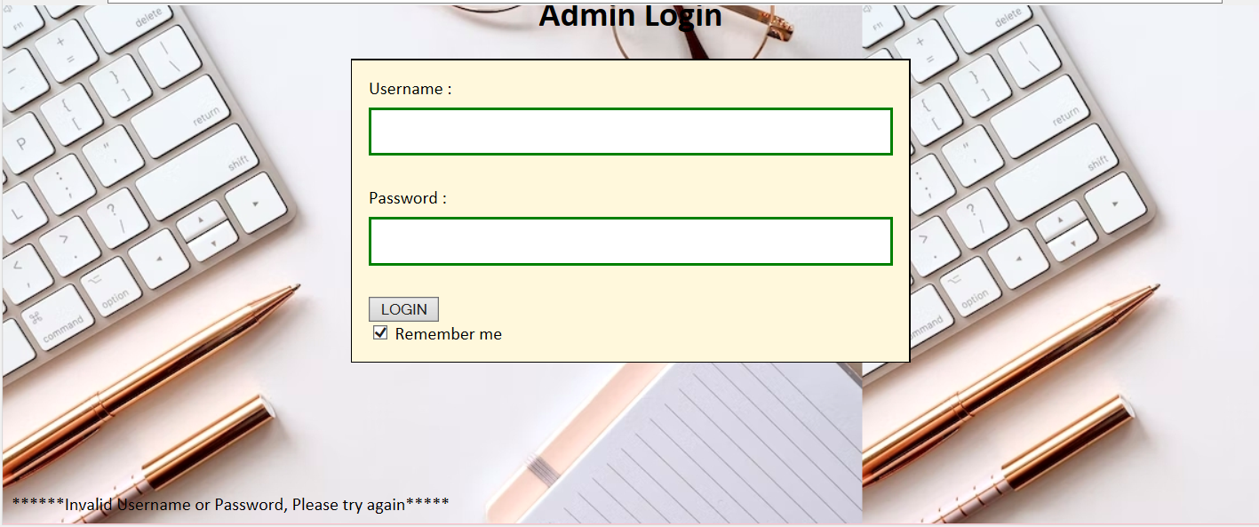

## **Step 15:** Writing a program to Assign Teacher to class 8 and 9;

package com;

import java.io.IOException;

import java.io.PrintWriter;

import java.sql.Connection;

import java.sql.DriverManager;

import java.sql.ResultSet;

import java.sql.Statement;

import java.util.ArrayList;

import java.util.List;

import javax.servlet.ServletException;

import javax.servlet.http.Cookie;

import javax.servlet.http.HttpServlet;

import javax.servlet.http.HttpServletRequest;

import javax.servlet.http.HttpServletResponse;

import java.sql.PreparedStatement;

/**

* Servlet implementation class AssignTo

*/

public class AssignTo extends HttpServlet {

private static final long serialVersionUID = 1L;

/**

* @see HttpServlet#HttpServlet()

*/

public AssignTo() {

super();

// TODO Auto-generated constructor stub

}

/**

* @see HttpServlet#doGet(HttpServletRequest request, HttpServletResponse response)

*/

protected void doGet(HttpServletRequest request, HttpServletResponse response) throws ServletException, IOException {

PrintWriter out = response.getWriter();

Cookie[] name = request.getCookies();

int ck = Integer.parseInt(name[0].getValue());

String teacher = null;

String subj = request.getParameter("sub");

try {

Class.forName("com.mysql.jdbc.Driver");

Connection connect = DriverManager.getConnection("jdbc:mysql://localhost:3306/school","root","Invisible16");

Statement stmt = connect.createStatement();

ResultSet rs = stmt.executeQuery("select name from listteachers where subject="+"'"+subj+"'");

while(rs.next()) {

teacher = rs.getString("name");

}

Statement stmt1 = connect.createStatement();

ResultSet rs1 = stmt1.executeQuery("select name,ID from liststudents where class="+"'"+name[0].getValue()+"'");

List<String> stud = new ArrayList<String>();

List<Integer> studId = new ArrayList<Integer>();

while(rs1.next()) {

stud.add(rs1.getString("name"));

studId.add(rs1.getInt("Id"));

}

rs1.close();

for(int i = 0;i < 3;i++) {

PreparedStatement stmt2 = connect.prepareStatement("insert into classreport values(?,?,?,?,?)");

stmt2.setInt(1, studId.get(i));

stmt2.setString(2, stud.get(i));

stmt2.setString(3,subj);

stmt2.setInt(4, ck);

stmt2.setString(5,teacher);

stmt2.execute();

stmt2.close();

}

out.println("<body bgcolor='brown'><h4>Teacher Assigned</h4><a href='Admin.html'>Go Back to Main</body>");

}

catch (Exception e) {

System.out.println(e);

}

}

/**

* @see HttpServlet#doPost(HttpServletRequest request, HttpServletResponse response)

*/

protected void doPost(HttpServletRequest request, HttpServletResponse response) throws ServletException, IOException {

// TODO Auto-generated method stub

doGet(request, response);

}

}

**OUTPUT:**



## **Step 16:** Writing a program to Assign Teacher to class 10;

package com;

import java.io.IOException;

import java.io.PrintWriter;

import java.sql.Connection;

import java.sql.DriverManager;

import java.sql.PreparedStatement;

import java.sql.ResultSet;

import java.sql.Statement;

import java.util.ArrayList;

import java.util.List;

import javax.servlet.ServletException;

import javax.servlet.http.Cookie;

import javax.servlet.http.HttpServlet;

import javax.servlet.http.HttpServletRequest;

import javax.servlet.http.HttpServletResponse;

/**

* Servlet implementation class AssignTo10

*/

public class AssignTo10 extends HttpServlet {

private static final long serialVersionUID = 1L;

/**

* @see HttpServlet#HttpServlet()

*/

public AssignTo10() {

super();

// TODO Auto-generated constructor stub

}

/**

* @see HttpServlet#doGet(HttpServletRequest request, HttpServletResponse response)

*/

protected void doGet(HttpServletRequest request, HttpServletResponse response) throws ServletException, IOException {

PrintWriter out = response.getWriter();

Cookie[] name = request.getCookies();

int cook = Integer.parseInt(name[0].getValue());

String teacher = null;

String subj = request.getParameter("sub");

try {

Class.forName("com.mysql.jdbc.Driver");

Connection connect = DriverManager.getConnection("jdbc:mysql://localhost:3306/school","root","Invisible16");

Statement stmt = connect.createStatement();

ResultSet rs = stmt.executeQuery("select name from listteachers where subject="+"'"+subj+"'");

while(rs.next()) {

teacher = rs.getString("name");

}

Statement stmt1 = connect.createStatement();

ResultSet rs1 = stmt1.executeQuery("select name,ID from liststudents where class="+"'"+name[0].getValue()+"'");

List<String> stud = new ArrayList<String>();

List<Integer> studId = new ArrayList<Integer>();

while(rs1.next()) {

stud.add(rs1.getString("name"));

studId.add(rs1.getInt("Id"));

}

rs1.close();

for(int i = 0;i < 3;i++) {

PreparedStatement stmt2 = connect.prepareStatement("insert into classreport values(?,?,?,?,?)");

stmt2.setInt(1, studId.get(i));

stmt2.setString(2, stud.get(i));

stmt2.setString(3,subj);

stmt2.setInt(4, cook);

stmt2.setString(5,teacher);

stmt2.execute();

stmt2.close();

}

out.println("<body bgcolor='brown'><h4>Teacher Assigned</h4><a href='Admin.html'>Go Back to Main</body>");

} catch (Exception e) {

out.println("Teacher assigned , GOTO MAIN Menu and click on ClASS REPORT to view the details");

}

}

/**

* @see HttpServlet#doPost(HttpServletRequest request, HttpServletResponse response)

*/

protected void doPost(HttpServletRequest request, HttpServletResponse response) throws ServletException, IOException {

// TODO Auto-generated method stub

doGet(request, response);

}

}

**OUTPUT:**



## **Step 17:** Writing a program to Assign Subject to a class:

package com;

import java.io.IOException;

import java.io.PrintWriter;

import java.sql.Connection;

import java.sql.DriverManager;

import java.sql.ResultSet;

import java.sql.Statement;

import javax.servlet.ServletException;

import javax.servlet.http.Cookie;

import javax.servlet.http.HttpServlet;

import javax.servlet.http.HttpServletRequest;

import javax.servlet.http.HttpServletResponse;

import com.mysql.jdbc.PreparedStatement;

/**

* Servlet implementation class AssignServlet

*/

public class AssignServlet extends HttpServlet {

private static final long serialVersionUID = 1L;

/**

* @see HttpServlet#HttpServlet()

*/

public AssignServlet() {

super();

// TODO Auto-generated constructor stub

}

/**

* @see HttpServlet#doGet(HttpServletRequest request, HttpServletResponse response)

*/

protected void doGet(HttpServletRequest request, HttpServletResponse response) throws ServletException, IOException {

PrintWriter out = response.getWriter();

String selectedClass = request.getParameter("r1");

Cookie ck = new Cookie("Class",selectedClass);

response.addCookie(ck);

if(selectedClass.equals("8") || selectedClass.equals("9")) {

out.println("<body style=\"background-image: url('css/back.jpg');\"><br><br><br><center><h4>Select subject to assign:</h4><form action='AssignTo'>");

out.println("<input type='radio' name='sub' value='Hindi'>Hindi<br>");

out.println("<input type='radio' name='sub' value='English'>English<br>");

out.println("<input type='radio' name='sub' value='Maths'>Maths<br>");

out.println("<input type='radio' name='sub' value='Science'>Science<br>");

out.println("<input type='radio' name='sub' value='SST'>SST<br>");

out.println("<input type='submit' value='ASSIGN TEACHER'>");

out.println("</form></body>");

}

if(selectedClass.equals("10")) {

out.println("<body style=\"background-image: url('css/back.jpg');\"><br><br><br><center><h4>Select subject to assign:</h4><form action='AssignTo10'>");

out.println("<input type='radio' name='sub' value='Hindi'>Hindi<br>");

out.println("<input type='radio' name='sub' value='English'>English<br>");

out.println("<input type='radio' name='sub' value='Maths'>Maths<br>");

out.println("<input type='radio' name='sub' value='Science'>Science<br>");

out.println("<input type='radio' name='sub' value='SST'>SST<br>");

out.println("<input type='radio' name='sub' value='Computer Basics'>Computer Basics<br>");

out.println("<input type='submit' value='ASSIGN TEACHER'>");

out.println("</form></body>");

}

}

/**

* @see HttpServlet#doPost(HttpServletRequest request, HttpServletResponse response)

*/

protected void doPost(HttpServletRequest request, HttpServletResponse response) throws ServletException, IOException {

// TODO Auto-generated method stub

doGet(request, response);

}

}

## **Step 18:** Writing a program Establish connection to database via XML file:

<Context>

<Resource name=*"jdbc_database"*

auth=*"Container"* type=*"javax.sql.DataSource"*

maxActive=*"20"* maxIdle=*"5"* maxWait=*"10000"*

username=*"root"* password=*"Invisible16"*

driverClassName=*"com.mysql.cj.jdbc.Driver"*

url=*"jdbc:mysql://localhost:3306/school"*/>

</Context>

**Creating Database and tables:**

CREAT Database school;

-- Table structure for table `allsubjects`

--

DROP TABLE IF EXISTS `allsubjects`;

/*!40101 SET @saved_cs_client = @@character_set_client */;

/*!50503 SET character_set_client = utf8mb4 */;

CREATE TABLE `allsubjects` (

`Subjects` varchar(20) DEFAULT NULL,

`type` varchar(10) DEFAULT NULL

) ENGINE=InnoDB DEFAULT CHARSET=utf8mb4 COLLATE=utf8mb4_0900_ai_ci;

/*!40101 SET character_set_client = @saved_cs_client */;

--

-- Dumping data for table `allsubjects`

--

LOCK TABLES `allsubjects` WRITE;

/*!40000 ALTER TABLE `allsubjects` DISABLE KEYS */;

INSERT INTO `allsubjects` VALUES ('Hindi','Regular'),('English','Regular'),('Maths','Regular'),('Science','Regular'),('SST','Regular'),('Computer Basics','Elective');

/*!40000 ALTER TABLE `allsubjects` ENABLE KEYS */;

UNLOCK TABLES;

--

-- Table structure for table `classreport`

--

DROP TABLE IF EXISTS `classreport`;

/*!40101 SET @saved_cs_client = @@character_set_client */;

/*!50503 SET character_set_client = utf8mb4 */;

CREATE TABLE `classreport` (

`StudentId` int DEFAULT NULL,

`StudentName` varchar(20) DEFAULT NULL,

`Subject` varchar(20) DEFAULT NULL,

`Class` int DEFAULT NULL,

`TeacherAssign` varchar(20) DEFAULT NULL

) ENGINE=InnoDB DEFAULT CHARSET=utf8mb4 COLLATE=utf8mb4_0900_ai_ci;

/*!40101 SET character_set_client = @saved_cs_client */;

--

-- Dumping data for table `classreport`

--

LOCK TABLES `classreport` WRITE;

/*!40000 ALTER TABLE `classreport` DISABLE KEYS */;

INSERT INTO `classreport` VALUES (11,'Piyush Agarwal','Hindi',8,'Isha Gupta'),(12,'Jhanvi gada','Hindi',8,'Isha Gupta'),(13,'Vaibhav Bhardwaj','Hindi',8,'Isha Gupta'),(31,'Ankush Kushwaha','Computer Basics',10,'Kishore Kumar'),(32,'Deepak kumar','Computer Basics',10,'Kishore Kumar'),(33,'Akanksha Rawat','Computer Basics',10,'Kishore Kumar'),(11,'Piyush Agarwal','Maths',8,'Adityaram Rao'),(12,'Jhanvi gada','Maths',8,'Adityaram Rao'),(13,'Vaibhav Bhardwaj','Maths',8,'Adityaram Rao'),(11,'Piyush Agarwal','Hindi',8,'Ishika Gupt'),(12,'Jhanvi gada','Hindi',8,'Ishika Gupt'),(13,'Vaibhav Bhardwaj','Hindi',8,'Ishika Gupt'),(31,'Ankush Kushwaha','Hindi',10,'Ishika Gupt'),(32,'Deepak kumar','Hindi',10,'Ishika Gupt'),(33,'Akanksha Rawat','Hindi',10,'Ishika Gupt'),(11,'Piyush Agarwal','SST',8,'Shilish Kumar'),(12,'Jhanvi gada','SST',8,'Shilish Kumar'),(13,'Vaibhav Bhardwaj','SST',8,'Shilish Kumar'),(22,'Akash kumar','Science',9,'Shivangini Pillay'),(23,'NishiKant','Science',9,'Shivangini Pillay'),(24,'Pooja Bhatt','Science',9,'Shivangini Pillay');

/*!40000 ALTER TABLE `classreport` ENABLE KEYS */;

UNLOCK TABLES;

--

-- Table structure for table `liststudents`

--

DROP TABLE IF EXISTS `liststudents`;

/*!40101 SET @saved_cs_client = @@character_set_client */;

/*!50503 SET character_set_client = utf8mb4 */;

CREATE TABLE `liststudents` (

`ID` int DEFAULT NULL,

`Name` varchar(20) DEFAULT NULL,

`Class` int DEFAULT NULL

) ENGINE=InnoDB DEFAULT CHARSET=utf8mb4 COLLATE=utf8mb4_0900_ai_ci;

/*!40101 SET character_set_client = @saved_cs_client */;

--

-- Dumping data for table `liststudents`

--

LOCK TABLES `liststudents` WRITE;

/*!40000 ALTER TABLE `liststudents` DISABLE KEYS */;

INSERT INTO `liststudents` VALUES (11,'Piyush Agarwal',8),(12,'Jhanvi gada',8),(13,'Vaibhav Bhardwaj',8),(22,'Akash kumar',9),(23,'NishiKant',9),(24,'Pooja Bhatt',9),(31,'Ankush Kushwaha',10),(32,'Deepak kumar',10),(33,'Akanksha Rawat',10);

/*!40000 ALTER TABLE `liststudents` ENABLE KEYS */;

UNLOCK TABLES;

--

-- Table structure for table `listteachers`

--

DROP TABLE IF EXISTS `listteachers`;

/*!40101 SET @saved_cs_client = @@character_set_client */;

/*!50503 SET character_set_client = utf8mb4 */;

CREATE TABLE `listteachers` (

`Name` varchar(20) DEFAULT NULL,

`Subject` varchar(20) DEFAULT NULL

) ENGINE=InnoDB DEFAULT CHARSET=utf8mb4 COLLATE=utf8mb4_0900_ai_ci;

/*!40101 SET character_set_client = @saved_cs_client */;

--

-- Dumping data for table `listteachers`

--

LOCK TABLES `listteachers` WRITE;

/*!40000 ALTER TABLE `listteachers` DISABLE KEYS */;

INSERT INTO `listteachers` VALUES ('Sayeda Tahseen','English'),('Ishika Gupt','Hindi'),('Adityaram Rao','Maths'),('Shilish Kumar','SST'),('Shivangini Pillay','Science'),('Kaif Kaur','Computer Basics');

/*!40000 ALTER TABLE `listteachers` ENABLE KEYS */;

UNLOCK TABLES;

--

-- Table structure for table `login`

-- DROP TABLE IF EXISTS `mystudent`;

/*!40101 SET @saved_cs_client = @@character_set_client */;

/*!50503 SET character_set_client = utf8mb4 */;

CREATE TABLE `mystudent` (

`id` int NOT NULL,

`Place` varchar(255) DEFAULT NULL,

`StName` varchar(255) DEFAULT NULL,

PRIMARY KEY (`id`)

) ENGINE=InnoDB DEFAULT CHARSET=utf8mb4 COLLATE=utf8mb4_0900_ai_ci;

/*!40101 SET character_set_client = @saved_cs_client */;

--

-- Dumping data for table `mystudent`

--

LOCK TABLES `mystudent` WRITE;

/*!40000 ALTER TABLE `mystudent` DISABLE KEYS */;

INSERT INTO `mystudent` VALUES (21,'Delhi','Ashuma'),(22,'Mumbai','Mercy da'),(24,'Bangalore','Payal'),(100,'Goa','Mortal');

/*!40000 ALTER TABLE `mystudent` ENABLE KEYS */;

UNLOCK TABLES;

/*!40103 SET TIME_ZONE=@OLD_TIME_ZONE */;

/*!40101 SET SQL_MODE=@OLD_SQL_MODE */;

/*!40014 SET FOREIGN_KEY_CHECKS=@OLD_FOREIGN_KEY_CHECKS */;

/*!40014 SET UNIQUE_CHECKS=@OLD_UNIQUE_CHECKS */;

/*!40101 SET CHARACTER_SET_CLIENT=@OLD_CHARACTER_SET_CLIENT */;

/*!40101 SET CHARACTER_SET_RESULTS=@OLD_CHARACTER_SET_RESULTS */;

/*!40101 SET COLLATION_CONNECTION=@OLD_COLLATION_CONNECTION */;

/*!40111 SET SQL_NOTES=@OLD_SQL_NOTES */;

-- Dump completed on 2022-09-28 17:59:18

Output:

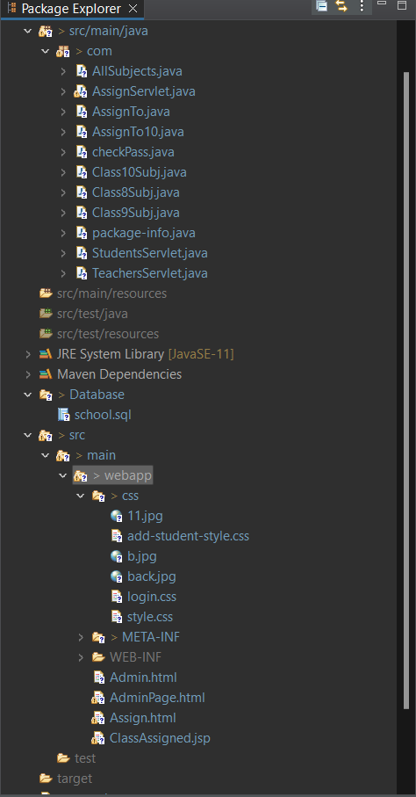

## **Step 6:** Pushing the code to GitHub repository

* Open your command prompt and navigate to the folder where you have created your files.

**cd <folder path>**

* Initialize repository using the following command:

**git init**

* Add all the files to your git repository using the following command:

**git add .**

* Commit the changes using the following command:

**git commit . -m <commit message>**

* Push the files to the folder you initially created using the following command:

**git push -u origin master**

## Conclusions

* You can view the complete record of the teaches assigned to class
* You can view complete teachers list
* You can view complete Student list
* You can view complete Subject list as per class